**Sustainable Outreach And Universal**

**Leadership (SOUL) Limited**

**Software Requirement Specification (SRS)**

Of

**Infrastructure Management and Maintenance** For Implementation of

**Campus Management Software**

at

**World Skill Center (WSC)**

**Table of Content**

A. Abstract 3

B. Introduction 3

C. Definition, Acronyms and Abbreviations 3

D. Overview of the Document 3

E. Scope of Education Module 4

F. WSC Infrastructure Management Process Flow 4

G. WSC Infrastructure Maintenance Process Flow 4

H. Process Flow Description 4

I. List of Screen and their descriptions 4

1. Infrastructure Management 6

1.1. Land 6

1.2. Building 7

1.3. Floor 9

1.4. Building Room 11

1.5. Building type Room 13

2. Infrastructure Maintenance 14

2.1. Asset 14

2.2. Asset Maintenance Team 19

2.3. Asset Maintenance 21

2.4. Asset Maintenance Log 23

2.5. Asset Repair 24

# Abstract

Software Requirements Gathering is one of the first phases of system development. This phase results in the Software Requirements Specification (SRS) document, which must contain a complete, concise, high-quality description of the system being considered.

# Introduction

The World Skill Center (WSC) is a premier advanced skill training institute established by the Government of Odisha, Skill Development and Technical Education Department, through the Odisha Skill Development Authority (OSDA). The WSC will impart advanced skill training in eight trades from engineering and service sectors. WSC caters primarily to induct the best talent from ITIs and Polytechnics and train them to become globally employable in emerging areas such as "Industry 4.0". WSC is housed in a state-of-the-art, 18-storey, air-conditioned building with nearly half a million square feet of space in the heart of capital city of Bhubaneswar.

With the Implementation of campus management software for WSC the goal is to streamline the operations and functions of the campus by integrating various processes, such as admissions, course registration, academic progress tracking, and financial management, HRMS, Procurement and Inventory management, etc into a unified system. The implementation also aims at providing a user-friendly interface for all stakeholders, making it easier for them to access the necessary information and complete their tasks with ease. The modules to be covered during the implementation of the software includes:

|  |  |
| --- | --- |
| Students Management Modules | Infrastructure Management |
| Academic System | Finance and Accounting System |
| Procurement & Inventory Management | Training and Placement |
| Human Resources Management System | Application Integration |

# Definition, Acronyms and Abbreviations

The following table explains the terms and abbreviations used in the document:

|  |  |
| --- | --- |
| **Abbreviation** | **Description** |
| SRS | Software Requirements Specification |
| SLCM | Student Life Cycle Management |
| R | Rename - When a field is Renamed |
| N | New - When a New field is Added |
| D | Delete - When an Existing field is Deleted |
| NA | Not Applicable |

# Overview of the Document

This requirement document provides a detailed overview of the functional requirements of a project. It serves as a communication tool between stakeholders, including developers, project managers, and end-users. The purpose of this requirement document is to define and document the project's objectives, scope, and expectations, and to ensure that all stakeholders have a clear understanding of what the project entails.

This document covers all the functional requirements of the **Infrastructure Management & Maintenance module** of ERP Product. This module helps in organizing the infrastructure of an organisation from land, building, floors and its rooms. The modules also help in maintenance of the assets present on the floor as well as floors.

# Scope of **Infrastructure Management & Maintenance module**

* Master data for Land, Buildings and Floor
* Room Master
* Asset Maintenance and AMC

# WSC Infrastructure Management & Maintenance Process Flow

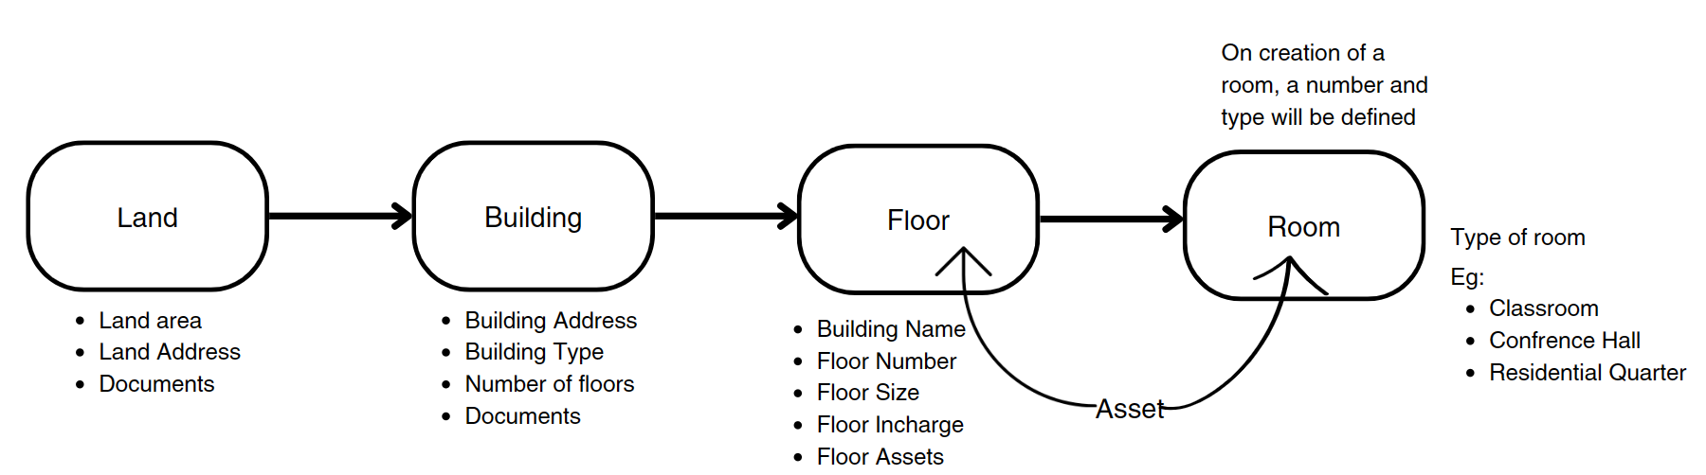

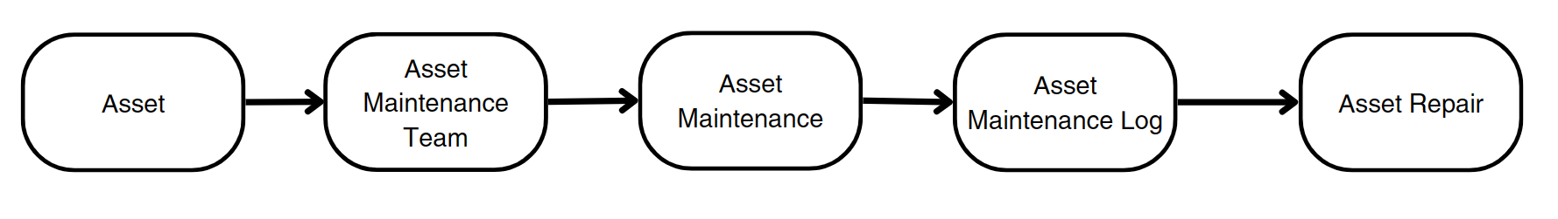

# Process Flow Description

1. The user will create land by filling up the fields like: Land Address, type of land and attaching documents.
2. The user will further create records for the building by going on to the building screen, where the user will maintain building details like building address, building type, number of floors and number of rooms, and attach the relevant documents.
3. Further, the user can create records of each floor by going to the floor master screen and maintaining details like Building Name, Floor number, Building Name, Floor size, Floor in-charge, attach floor documents and the assets on the floor.
4. Finally, the user will create and assign rooms in the building and maintain details like room number, room type, floor number, and the assets present in the room.
5. Now coming to the asset maintenance part, the assets mentioned in Floor and Building Room can be maintained by scheduling a routine maintenance and maintenance team can be created, which will further log the maintenance.
6. Once the maintenance is conducted it can be updated using the Asset Repair screen.

# List of Screen and their descriptions

The following tables lists the pages used in Academics module :

|  |  |  |
| --- | --- | --- |
| **Sl. No.** | **Screen Name** | **Description** |
| 1 | Land | This is a master screen which holds data regarding the land. Land here is in reference to the plot of land on which the building is built. |
| 2 | Building | This is a master screen for buildings. All the building information shall be stored here including documents like Building Letter(Records of right and Building design), Fire Approval, Electrical Inspection, etc. |
| 3 | Floor | The Floor Master Screen is a screen which will help the user to manage and track the layout of a building's floors and associated fixed assets. |
| 4 | Building Room | **This is a master screen, in which we shall be storing the building’s room details and classifying the rooms. This screen also help us assign a number to the residence** |
| 5 | Building type Room | **This screen helps define the type of the room, for example if it is a classroom or residential or conference hall.** |
| 6 | Type of Residence | **This screen helps in the classification of residence, whether it shall be a quarter or a duplex or even a villa.** |
| 7 | Residence Type | **This screen helps in further classification of residences in a building room based on types of residence. Example: 2BHK Quarter or 4BHK Villa and so on** |
| 8 | Asset | The Asset screem will help maintain fixed asset records for Company assets like computers, furnitures, cars, etc. and manage their depreciations, sale, or disposal. User can track locations of the assets or keep records of employees who are using the asset. |
| 9 | Asset Maintenance Team | The Asset Maintenance Team screen will help the user create team which will be responsible for carrying out maintenance activities on the Asset. |
| 10 | Asset Maintenance | Asset Maintenance screen will help maintain any activity done on Assets to maintain their performance or condition. |
| 11 | Asset Maintenance Log | Asset Maintenance Log will assist the user to log the tasks carried out in an Asset Maintenance. |
| 12 | Asset Repair | Asset Repair will help the user maintain any activity carried to repair a broken Asset to restore full functionality. |

# Infrastructure Management

## **Land**

**General Description**

|  |  |
| --- | --- |
| **Description** | This is a master screen which holds data regarding the land. Land here is in reference to the plot of land on which the building is built. The Land Master shall have attachment buttons for Allotment Letter and other documents.  Operations on this screen can be performed by the administrator only. |
| **Navigation** | NA |
| **Pre-requisites** | NA |

**Screenshot**

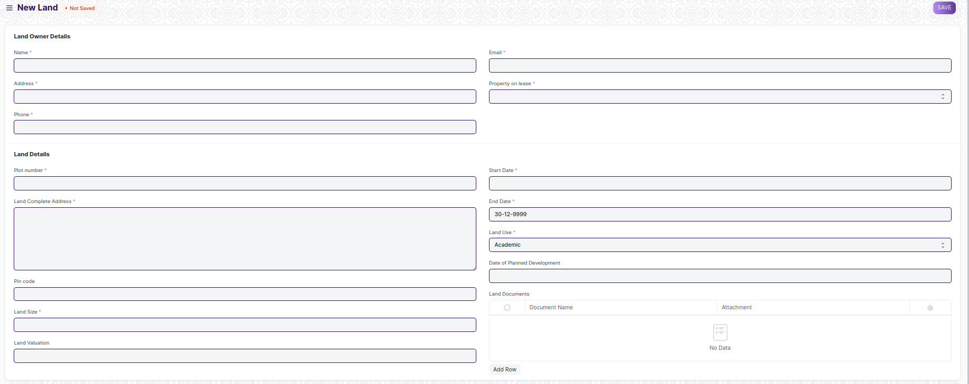

Figure 1: Land

**Field List**

The “Land” screen shall consist of the following fields:

|  |  |  |  |  |  |
| --- | --- | --- | --- | --- | --- |
| **ID** | **Field Label** | **Field Type** | **Validation/Action** | **Mandatory** | **Remarks** |
| 1 | Name | Text Field |  | Y |  |
| 2 | Address | Text Field |  | Y |  |
| 3 | Phone | Text Field |  | Y |  |
| 4 | Email | Text Field |  | Y |  |
| 5 | Property on lease | Select | Yes  No | Y |  |
| 6 | Lease | Attach |  |  |  |
| 7 | Plot number | Data |  | Y |  |
| 8 | Land Complete Address | Small Text Field |  | Y |  |
| 9 | Pin code | Text Field |  |  |  |
| 10 | Land Size | Text Field |  | Y |  |
| 11 | Land Valuation | Currency |  |  |  |
| 12 | Start Date | Date |  | Y |  |
| 13 | End Date | Date |  | Y |  |
| 14 | Land Use | Drop down | Academic  Residential  Others | Y |  |
| 15 | Land Use, If others | Text Field |  | Display Depends on Land use drop down selection(others) |  |
| 16 | Date of Planned Development | Date |  |  |  |
| **17** | **Land Documents** | Table |  |  |  |

|  |  |  |  |  |  |
| --- | --- | --- | --- | --- | --- |
| **Land Documents** | | | | | |
| **ID** | **Field Label** | **Field Type** | **Validation/Action** | **Mandatory** | **Remarks** |
| 1 | Document Name | Text Field | User Input |  |  |
| 2 | Document | Attach Button |  |  |  |

**User: Roles & Permission**

The following table describes the users and their roles and permissions for the screens:

|  |  |  |  |  |  |  |  |  |  |  |
| --- | --- | --- | --- | --- | --- | --- | --- | --- | --- | --- |
| **ID** | | **Role** | **Select** | **Read** | **Write** | **Create** | **Delete** | **Submit** | **Cancel** | **Amend** |
| 1 | Building Administrator | | Yes | Yes | Yes | Yes | Yes | NA | NA | NA |
| 2 | Floor Supervisor | | No | Yes | No | No | No | NA | NA | NA |
| 3 | Maintenance Department | | No | Yes | No | No | No | NA | NA | NA |
| 4 | Employee | | No | No | No | No | No | No | No | No |

## **Building**

**General Description**

|  |  |
| --- | --- |
| **Description** | This is a master screen for buildings. All the building information shall be stored here including documents like Building Letter(Records of right and Building design), Fire Approval, Electrical Inspection, etc. The buildings can be residential, academic or both. The actions on this screen can be performed by the administrator only. |
| **Navigation** | NA |
| **Pre-requisites** | Land(if exists) |

**Screenshot**

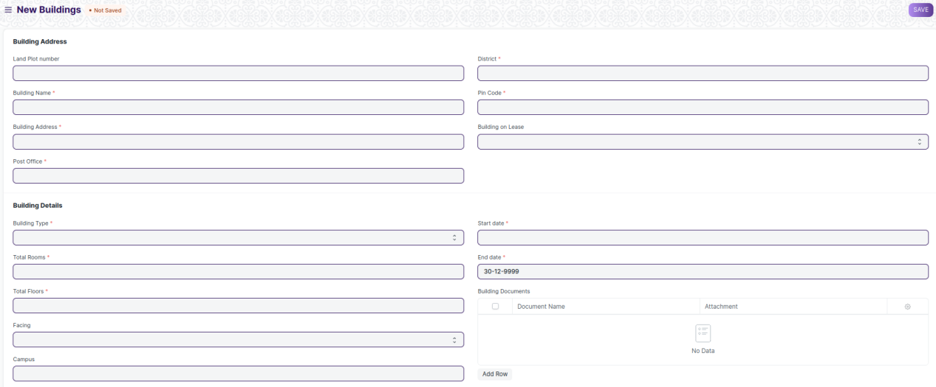

Figure 2: Building

**Field List**

The “Building” screen shall consist of the following fields:

|  |  |  |  |  |  |
| --- | --- | --- | --- | --- | --- |
| **ID** | **Field Label** | **Field Type** | **Validation/Action** | **Mandatory** | **Remarks** |
| 1 | Land Plot number | Link Field | Fetched from Land master screen |  |  |
| 2 | Land Address | Text Field | Auto fetch based on Land Plot Number |  |  |
| 3 | Building Name | Text Field | User Input | Y |  |
| 4 | Building Address | Text Field |  | Y |  |
| 5 | Post Office | Text Field |  | Y |  |
| 6 | District | Link Field | Districts | Y |  |
| 7 | State | Text Field |  | Y |  |
| 8 | Pin Code | Text Field |  | Y |  |
| 9 | Building on Lease | Drop down | Yes  No | Y |  |
| 10 | Lease | Attach | Display Depends on “Building on Lease” | Y |  |
| 11 | Building Type | Drop down | Academic  Administrative  Others | Y |  |
| 12 | Building Type, if any other | Text Field |  | Display Depends on “Building Type” drop down selection(others) |  |
| 13 | Total Rooms | Integer Field |  |  |  |
| 14 | Total Floors | Integer Field |  | Y |  |
| 15 | Facing | Drop down | North  South  East  West | Y |  |
| 16 | Campus | Text Field |  |  |  |
| 17 | Start date | Date picker |  |  |  |
| 18 | End date | Date picker |  |  |  |
| **19** | **Building Documents** | Attach |  |  |  |

|  |  |  |  |  |  |
| --- | --- | --- | --- | --- | --- |
| **Building Documents** | | | | | |
| **ID** | **Field Label** | **Field Type** | **Validation/Action** | **Mandatory** | **Remarks** |
| 1 | Document Name | Text Field |  |  |  |
| 2 | Document | Attach Button |  |  |  |

**User: Roles & Permission**

The following table describes the users and their roles and permissions for the screens:

|  |  |  |  |  |  |  |  |  |  |
| --- | --- | --- | --- | --- | --- | --- | --- | --- | --- |
| **ID** | **Role** | **Select** | **Read** | **Write** | **Create** | **Delete** | **Submit** | **Cancel** | **Amend** |
| 1 | Building Administrator | Yes | Yes | Yes | Yes | Yes | NA | NA | NA |
| 2 | Floor Supervisor | No | Yes | No | No | No | NA | NA | NA |
| 3 | Maintenance Department | No | Yes | No | No | No | NA | NA | NA |
| 4 | Employee | No | No | No | No | No | NA | NA | NA |

## **Floor**

**General Description**

|  |  |
| --- | --- |
| **Description** | * The Floor Master Screen is a screen which will help the user to manage and track the layout of a building's floors and associated fixed assets. It provides an interface that allows users to view floor plans, assign fixed assets to specific locations, and record important maintenance information. * One of the key features of the Floor Master Screen is the ability to upload layout drawings, which can be used as a reference for future maintenance and planning. This feature allows users to quickly identify the location of specific assets or areas within the building, which can save time and reduce the risk of errors. * The Floor Master Screen allows users to record floor-wise details, such as assigning non-movable assets to specific locations. The application keeps this information in MM, but users can access it through the Infrastructure. This allows users to easily view the details of each floor and the assets assigned to it. |
| **Navigation** | NA |
| **Pre-requisites** | Building |

**Screenshot**

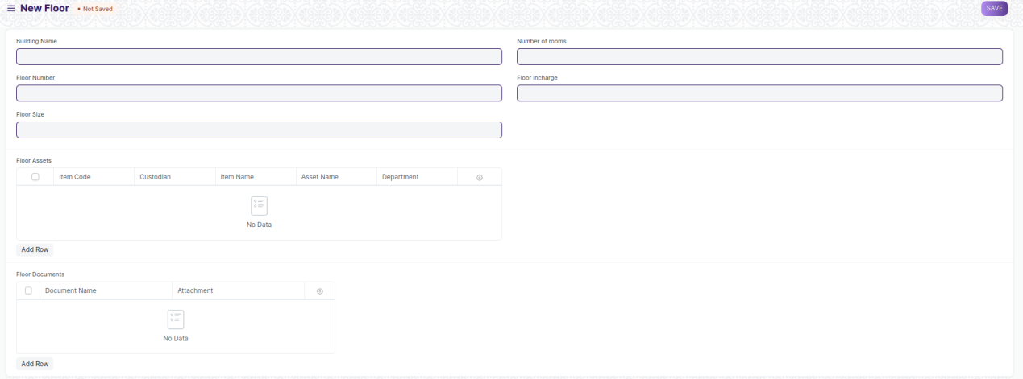

Figure 3: Floor

**Field List**

The “Floor” screen shall consist of the following fields:

|  |  |  |  |  |  |
| --- | --- | --- | --- | --- | --- |
| **ID** | **Field Label** | **Field Type** | **Validation/Action** | **Mandatory** | **Remarks** |
| 1 | Building Name | Link Field | Fetched from Building master screen | Y |  |
| 2 | Floor Number | Text Field |  | Y |  |
| 3 | Floor Size | Integer Field |  |  |  |
| 4 | Number of rooms | Text Field |  | Y |  |
| 5 | Floor Plan | Attach |  |  |  |
| 6 | Floor Incharge | Text Field |  |  |  |
| **7** | **Floor Assets** | Table |  |  |  |
| **8** | **Floor Documents** | Table |  |  |  |

|  |  |  |  |  |  |
| --- | --- | --- | --- | --- | --- |
| **Floor Assets** | | | | | |
| **ID** | **Field Label** | **Field Type** | **Validation/Action** | **Mandatory** | **Remarks** |
| 1 | Item Code | Link Field | Fetched from Item master screen | Y |  |
| 2 | Item Name | Text Field | Auto fetch based on Item Code |  |  |
| 3 | Location | Link Field | Fetched from Location master screen |  |  |
| 4 | Asset Name | Text Field | User Input |  |  |
| 5 | Custodian | Link Field | Fetched from Employee master screen | Y |  |
| 6 | Department | Link Field | Fetched from Department screen | Y |  |

|  |  |  |  |  |  |
| --- | --- | --- | --- | --- | --- |
| **Floor Documents** | | | | | |
| **ID** | **Field Label** | **Field Type** | **Validation/Action** | **Mandatory** | **Remarks** |
| 1 | Document Name | Text Field | User Input |  |  |
| 2 | Attachment | Attach Button |  |  |  |

**User: Roles & Permission**

The following table describes the users and their roles and permissions for the screens:

|  |  |  |  |  |  |  |  |  |  |  |
| --- | --- | --- | --- | --- | --- | --- | --- | --- | --- | --- |
| **ID** | | **Role** | **Select** | **Read** | **Write** | **Create** | **Delete** | **Submit** | **Cancel** | **Amend** |
| 1 | Building Administrator | | Yes | Yes | Yes | Yes | Yes | NA | NA | NA |
| 2 | Floor Supervisor | | No | Yes | No | No | No | NA | NA | NA |
| 3 | Maintenance Department | | No | Yes | No | No | No | NA | NA | NA |
| 4 | Employee | | No | No | No | No | No | NA | NA | NA |

## **Building Room**

**General Description**

|  |  |
| --- | --- |
| **Description** | **This is a master screen, in which we shall be storing the building’s room details and classifying the rooms. This screen also help us assign a number to the residence ( For e.g, Residence number).**  **The operations on this screen can be performed by the Administrator only.**  **In this screen, the user shall select the type of room and, based on selection, the type of residence shall be fetched.**  **Further on selection of type of residence, the residence type name(e.g. 2BHK) drop down shall be fetched.** |
| **Navigation** | NA |
| **Pre-requisites** |  |

**Screenshot**

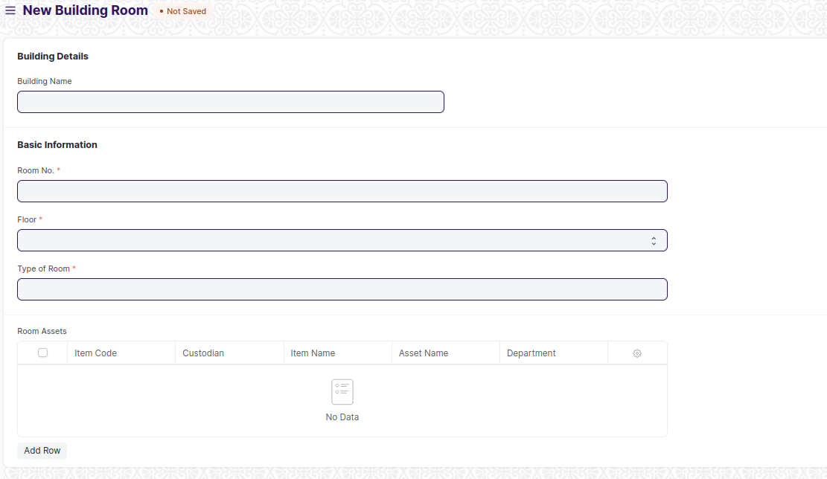

Figure 4: Building Room

**Field List**

The **“Building Room**” screen shall consist of the following fields:

|  |  |  |  |  |  |
| --- | --- | --- | --- | --- | --- |
| **ID** | **Field Label** | **Field Type** | **Validation/Action** | **Mandatory** | **Remarks** |
| 1 | Building Name | Link Field | Fetched from Building master screen |  |  |
| 2 | Building Type | Text Field | Auto fetch based on Building Name |  |  |
| 3 | Building Address | Text Field | Auto fetch based on Building Name | Y |  |
| 4 | Building's Land Plot number | Text Field | Auto fetch based on Building Name | Y |  |
| 5 | Building's Land Address | Text Field | Auto fetch based on Building Name | Y |  |
| 6 | District | Text Field | Auto fetch based on Building Name | Y |  |
| 7 | State | Text Field | Auto fetch based on Building Name | Y |  |
| 8 | Pin Code | Text Field | Auto fetch based on Building Name | Y |  |
| 9 | Room No. | Text Field |  | Y |  |
| 10 | Floor | Text Field | Ground  1 ….. |  |  |
| 11 | Type of Room | Link Field | Building type Room | Y |  |
| 12 | **Room Assets** | Table |  |  |  |

|  |  |  |  |  |  |
| --- | --- | --- | --- | --- | --- |
| **Room Assets** | | | | | |
| **ID** | **Field Label** | **Field Type** | **Validation/Action** | **Mandatory** | **Remarks** |
| 1 | Item Code | Link Field | Fetched from Item master screen | Y |  |
| 2 | Item Name | Text Field | Auto fetch based on Item Code |  |  |
| 3 | Location | Link Field | Fetched from Location master screen |  |  |
| 4 | Asset Name | Text Field | User Input |  |  |
| 5 | Custodian | Link Field | Fetched from Employee master screen | Y |  |
| 6 | Department | Link Field | Fetched from Department screen | Y |  |

**User: Roles & Permission**

The following table describes the users and their roles and permissions for the screens:

|  |  |  |  |  |  |  |  |  |  |
| --- | --- | --- | --- | --- | --- | --- | --- | --- | --- |
| **ID** | **Role** | **Select** | **Read** | **Write** | **Create** | **Delete** | **Submit** | **Cancel** | **Amend** |
| 1 | Building Administrator | Yes | Yes | Yes | Yes | Yes | NA | NA | NA |
| 2 | Floor Supervisor | No | Yes | No | No | No | NA | NA | NA |
| 3 | Maintenance Department | No | Yes | No | No | No | NA | NA | NA |
| 4 | Employee | No | No | No | No | No | NA | NA | NA |

## **Building type Room**

**General Description**

|  |  |
| --- | --- |
| **Description** | **This screen helps define the type of the room, for example if it is a classroom or residential or conference hall. The operations on this screen can be performed by the Administrator only.** |
| **Navigation** | Home > Infrastructure> Building Type Room |
| **Pre-requisites** |  |

**Screenshot**

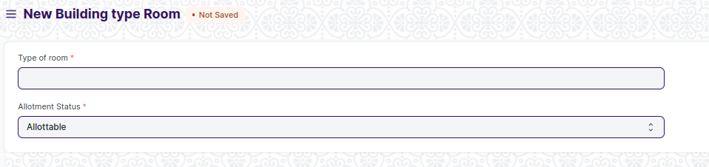

**Field List**

The **“Building Type Room**” screen shall consist of the following fields:

|  |  |  |  |  |  |
| --- | --- | --- | --- | --- | --- |
| **ID** | **Field Label** | **Field Type** | **Validation/Action** | **Mandatory** | **Remarks** |
| 1 | Type of Room | Text Field | User Input | Y |  |
| 2 | Allotment Status | Drop down | Allottable  Non Allottable | Y |  |

**User: Roles & Permission**

The following table describes the users and their roles and permissions for the screens:

|  |  |  |  |  |  |  |  |  |  |  |
| --- | --- | --- | --- | --- | --- | --- | --- | --- | --- | --- |
| **ID** | | **Role** | **Select** | **Read** | **Write** | **Create** | **Delete** | **Submit** | **Cancel** | **Amend** |
| 1 | Building Administrator | | Yes | Yes | Yes | Yes | Yes | NA | NA | NA |
| 2 | Floor Supervisor | | No | Yes | No | No | No | NA | NA | NA |
| 3 | Maintenance Department | | No | Yes | No | No | No | NA | NA | NA |
| 4 | Employee | | No | No | No | No | No | NA | NA | NA |

# Infrastructure Maintenance

## Asset

**General Description**

The Following table describe overall information about this screen:

|  |  |
| --- | --- |
| **Description** | In Asset, you can maintain fixed asset records for Company assets like computers, furnitures, cars, etc. and manage their depreciations, sale, or disposal. You can track locations of the assets or keep records of employees who are using the asset. You can also manage the maintenance details of the assets. |
| **Navigation** | Home > Material Management > Assets > Asset |
| **Pre-requisites** | 1. Item 2. Location 3. Custodian 4. Department 5. Cost Center 6. Purchase receipt/ Purchase Invoice 7. Finance Book |

**Screenshot**

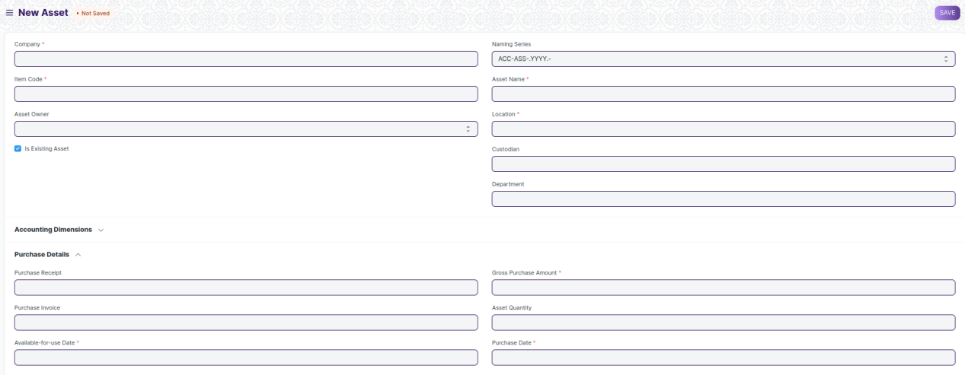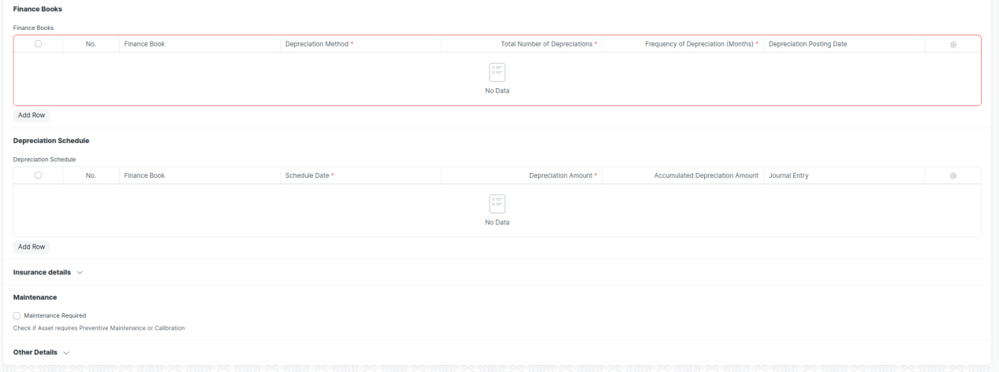

Figure 5: Asset Screen

**UI Fields**

The “Asset” screen shall consist of the following fields:

|  |  |  |  |  |  |  |
| --- | --- | --- | --- | --- | --- | --- |
| **ID** | **Field Label** | **Field Type** | **Validation/ Action** | **Mandatory** | **Remarks** | **R/N/D** |
| 1 | Company | Link | Fetched from Company screen | Yes |  |  |
| 2 | Item Code | Link | Fetched from Company screen | Yes |  |  |
| 3 | Item Name | Read Only | Populated based on selection of Item code |  |  |  |
| 4 | Asset Owner | Dropdown | Company/  Supplier /  Customer |  |  |  |
| 5 | Asset Owner Company | Link | Fetched from Company screen |  |  |  |
| 6 | Is Existing Asset | Checkbox | User Input |  |  |  |
| 7 | Supplier | Link | Fetched from Supplier screen |  |  |  |
| 8 | Customer | Link | Fetched from Customer screen |  |  |  |
| 9 | Image | Attach Image | User Input |  |  |  |
| 10 | Naming Series | Dropdown | ACC-ASS-.YYYY.- |  |  |  |
| 11 | Asset Name | Text Field | User Input | Yes |  |  |
| 12 | Asset Category | Link | Fetched from Asset Category screen |  |  |  |
| 13 | Location | Link | Fetched from Location screen | Yes |  |  |
| 14 | Custodian | Link | Fetched from Employee screen |  |  |  |
| 15 | Department | Link | Fetched from Department screen |  |  |  |
| 16 | Disposal Date | Date | User Input |  |  |  |
| 17 | Address | Link | Fetched from Address screen |  |  |  |
| 18 | Cost Center | Link | Fetched from Cost Center screen |  |  |  |
| 19 | Purchase Receipt | Link | Fetched from Purchase Invoice screen |  |  |  |
| 20 | Purchase Invoice | Link | Fetched from Purchase Invoice screen |  |  |  |
| 21 | Available-for-use Date | Date | User Input | Yes |  |  |
| 22 | Gross Purchase Amount | Currency | User Input | Yes |  |  |
| 23 | Asset Quantity | Int | User Input |  |  |  |
| 24 | Purchase Date | Date | User Input | Yes |  |  |
| 25 | Calculate Depreciation | Checkbox | User Input |  |  |  |
| 26 | Opening Accumulated Depreciation | Currency | User Input |  |  |  |
| 27 | Number of Depreciation's Booked | Int | User Input |  |  |  |
| 28 | **Finance Books** | Table | These table is describe below |  |  |  |
| 29 | Depreciation Method | Dropdown | Straight Line /  Double Declining Balance /  Manual |  |  |  |
| 30 | Value After Depreciation | Currency | User Input |  |  |  |
| 31 | Total Number of Depreciation's | Int | User Input |  |  |  |
| 32 | Frequency of Depreciation (Months) | Int | User Input |  |  |  |
| 33 | Next Depreciation Date | Date | User Input |  |  |  |
| 34 | **Depreciation Schedule** | Table | These table is describe below |  |  |  |
| 35 | Policy number | Text Field | User Input |  |  |  |
| 36 | Insurer | Text Field | User Input |  |  |  |
| 37 | Insured value | Text Field | User Input |  |  |  |
| 38 | Insurance Start Date | Date | User Input |  |  |  |
| 39 | Insurance End Date | Date | User Input |  |  |  |
| 40 | Comprehensive Insurance | Text Field | User Input |  |  |  |
| 41 | Maintenance Required | Checkbox | User Input |  |  |  |
| 42 | Status | Dropdown | Draft /  Submitted /  Partially Depreciated /  Fully Depreciated /  Sold /  Scrapped /  In Maintenance /  Out of Order /  Issue /  Receipt /  Capitalized /  Decapitalized |  |  |  |
| 43 | Booked Fixed Asset | Checkbox | User Input |  |  |  |
| 44 | Purchase Receipt Amount | Currency | User Input |  |  |  |
| 45 | Default Finance Book | Link | Fetched from Finance Book screen |  |  |  |
| 46 | Depreciation Entry Posting Status | Dropdown | Successful /  Failed |  |  |  |
| 47 | Manage | Button | Transfer Asset: On click of this button you can transfer Asset from One employee/Location to another |  |  |  |
| Scrap Asset: On click of this button you can scrap Asset |  |  |  |
| Sell Asset: On click of this button you can sell Asset |  |  |  |
| Maintain Asset: On click of this button you can create Maintenance schedule for an Asset |  |  |  |
| Repair Asset: On click of this button you can create repair details for an Asset |  |  |  |
| Split Asset: On click of this you can split Asset |  |  |  |
| Adjust Asset value: On click of this button you can see the value of Asset |  |  |  |
| View Ledger Entry: On click of this button you can view General entry for the Asset |  |  |  |

|  |  |  |  |  |  |  |
| --- | --- | --- | --- | --- | --- | --- |
| **Finance Books** | | | | | | |
| **ID** | **Field Label** | **Field Type** | **Validation/ Action** | **Mandatory** | **Remarks** | **R/N/D** |
| 1 | Finance Book | Link | Fetched from Finance book screen |  |  |  |
| 2 | Depreciation Method | Dropdown | Straight Line /  Double Declining Balance /  Written Down Value /  Manual | Yes |  |  |
| 3 | Total Number of Depreciation | Int | User Input | Yes |  |  |
| 4 | Frequency of Depreciation (Months) | Int | User Input | Yes |  |  |
| 5 | Depreciation Posting Date | Date | User Input |  |  |  |
| 6 | Expected Value After Useful Life | Currency | User Input |  |  |  |
| 7 | Value After Depreciation | Currency | User Input |  |  |  |
| 8 | Rate of Depreciation | Percent | User Input |  |  |  |

|  |  |  |  |  |  |  |
| --- | --- | --- | --- | --- | --- | --- |
| **Depreciation Schedule** | | | | | | |
| **ID** | **Field Label** | **Field Type** | **Validation/ Action** | **Mandatory** | **Remarks** | **R/N/D** |
| 1 | Finance Book | Link | Fetched from Finance book screen |  |  |  |
| 2 | Schedule Date | Date | User Input | Yes |  |  |
| 3 | Depreciation Amount | Currency | User Input | Yes |  |  |
| 4 | Accumulated Depreciation Amount | Currency | User Input |  |  |  |
| 5 | Journal Entry | Link | Fetched from Finance book screen |  |  |  |
| 6 | Make Depreciation Entry | Button | On click of this button make depreciation entry for Asset |  |  |  |
| 7 | Finance Book Id | Text Field | User Input |  |  |  |
| 8 | Depreciation Method | DropDown | User Input |  |  |  |

**Note:**

1. Asset report to be generated to differentiate between types of asset with remarks/comments
2. Stocks, Assets should be independent reports

**Users: Roles and Permissions**

The following table describes the users and their roles and permissions for the screens :

|  |  |  |  |  |  |  |  |  |  |
| --- | --- | --- | --- | --- | --- | --- | --- | --- | --- |
| **ID** | **Role** | **Select** | **Read** | **Write** | **Create** | **Delete** | **Submit** | **Cancel** | **Amend** |
|  | Building Administrator | Yes | Yes | Yes | Yes | Yes | Yes | Yes | Yes |
|  | Floor Supervisor | Yes | Yes | Yes | Yes | Yes | Yes | Yes | Yes |
|  | Maintenance Department | Yes | Yes | Yes | Yes | Yes | Yes | Yes | Yes |
|  | Employee | Yes | Yes | No | No | No | No | No | No |

## Asset Maintenance Team

**General Description**

The Following table describe overall information about this screen:

|  |  |
| --- | --- |
| **Description** | The Asset Maintenance Team is responsible for carrying out maintenance activities on the Asset. |
| **Navigation** | Home > Material Management > Maintenance> Asset Maintenance Team |
| **Pre-requisites** | 1. User 2. Role 3. Company |

**Screenshot**

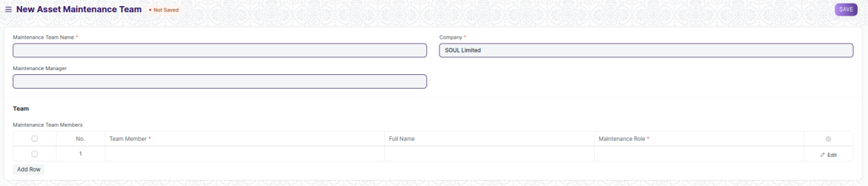

Figure 6: Asset Maintenance Team Screen

**UI Fields**

The “Asset Maintenance Team” screen shall consist of the following fields:

|  |  |  |  |  |  |  |
| --- | --- | --- | --- | --- | --- | --- |
| **ID** | **Field Label** | **Field Type** | **Validation/ Action** | **Mandatory** | **Remarks** | **R/N/D** |
| 1 | Maintenance Team Name | Text Field | User Input | Yes |  |  |
| 2 | Maintenance Manager | Link | Fetched from User screen |  |  |  |
| 3 | Maintenance Manager Name | Read Only | Fetched through Maintenance Manager |  |  |  |
| 4 | Company | Link | Fetched from Company screen | Yes |  |  |
| **5** | **Maintenance Team Members** | **Table** |  | Yes | These table is describe below |  |

|  |  |  |  |  |  |  |  |
| --- | --- | --- | --- | --- | --- | --- | --- |
| **Maintenance Team Members** | | | | | | | |
| **ID** | **Field Label** | **Field Type** | **Validation/ Action** | **Mandatory** | **Remarks** | | **R/N/D** |
| 1 | Team Member | Link | Fetched from User screen | Yes |  |  | |
| 2 | Full Name | Text Field | User Input |  |  |  | |
| 3 | Maintenance Role | Link | Fetched from Role screen | Yes |  |  | |

**Users: Roles and Permissions**

The following table describes the users and their roles and permissions for the screens :

|  |  |  |  |  |  |  |  |  |  |
| --- | --- | --- | --- | --- | --- | --- | --- | --- | --- |
| **ID** | **Role** | **Select** | **Read** | **Write** | **Create** | **Delete** | **Submit** | **Cancel** | **Amend** |
|  | Building Administrator | No | Yes | No | No | No | No | No | No |
|  | Floor Supervisor | No | Yes | No | No | No | No | No | No |
|  | Maintenance Department | Yes | Yes | Yes | Yes | Yes | Yes | Yes | Yes |
|  | Employee | No | Yes | No | No | No | No | No | No |

## Asset Maintenance

**General Description**

The Following table describe overall information about this screen:

|  |  |
| --- | --- |
| **Description** | Asset Maintenance refers to any activity done on Assets to maintain their performance or condition. |
| **Navigation** | Home > Material Management > Maintenance> Asset Maintenance |
| **Pre-requisites** | 1. Asset 2. Asset Maintenance Team 3. Company |

**Screenshot**

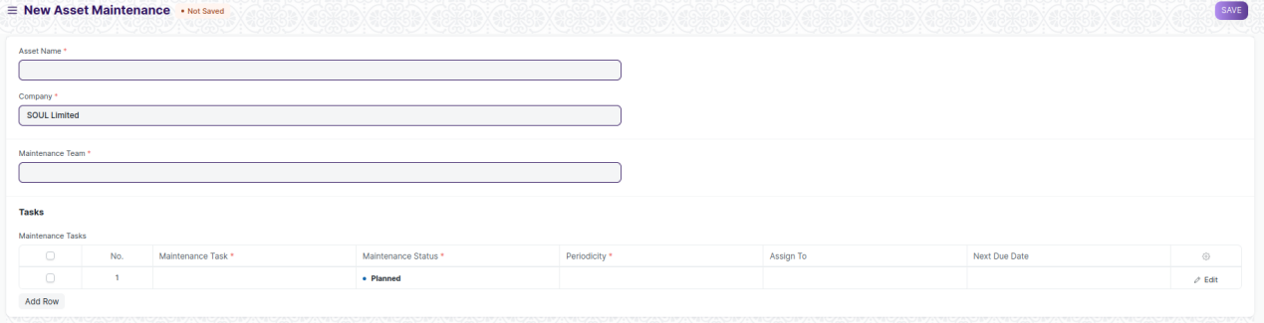

Figure 7: Asset Maintenance Screen

**UI Fields**

The “Asset Maintenance” screen shall consist of the following fields:

|  |  |  |  |  |  |  |
| --- | --- | --- | --- | --- | --- | --- |
| **ID** | **Field Label** | **Field Type** | **Validation/ Action** | **Mandatory** | **Remarks** | **R/N/D** |
| 1 | Asset Name | Link | Fetched from Asset screen | Yes |  |  |
| 2 | Asset Category | Read Only | Fetched from selected asset |  |  |  |
| 3 | Company | Link | Fetched from Company screen | Yes |  |  |
| 4 | Item Code | Read Only | Fetched from selected asset |  |  |  |
| 5 | Item Name | Read Only | Fetched from selected asset |  |  |  |
| 6 | Maintenance Team | Link | Fetched from Asset Maintenance Team screen | Yes |  |  |
| 7 | Maintenance Manager | Text Field | User Input |  |  |  |
| 8 | Maintenance Manager Name | Read Only | Fetched from selected Asset Maintenance Team |  |  |  |
| 9 | **Maintenance Tasks** | **Table** |  | **Yes** | These table is describe below |  |

|  |  |  |  |  |  |  |
| --- | --- | --- | --- | --- | --- | --- |
| **Maintenance Task** | | | | | | |
| **ID** | **Field Label** | **Field Type** | **Validation/ Action** | **Mandatory** | **Remarks** | **R/N/D** |
| 1 | Maintenance Task | Text Field | User Input | Yes |  |  |
| 2 | Maintenance Type | Select | Preventive Maintenance /  Calibration |  |  |  |
| 3 | Maintenance Status | Select | Planned / Overdue / Canceled | Yes |  |  |
| 4 | Start Date | Text Field | User Input | Yes |  |  |
| 5 | Periodicity | Select | Daily / Weekly / Monthly /  Quarterly / Yearly / 2 Yearly | Yes |  |  |
| 6 | End Date | Date | User Input |  |  |  |
| 7 | Certificate Required | Checkbox | User Input |  |  |  |
| 8 | Assign To | Link | Fetched from User screen |  |  |  |
| 9 | Assign to Name | Read Only | Feted from value selected from Assign to value |  |  |  |
| 10 | Next Due Date | Date | User Input |  |  |  |
| 11 | Last Completion Date | Date | User Input |  |  |  |
| 12 | Description | Text Editor | User Input |  |  |  |

**Note:**

1. Asset Maintenance, mail to be triggered when the maintenance tasks / maintenance

log is being recorded

**Users: Roles and Permissions**

The following table describes the users and their roles and permissions for the screens :

|  |  |  |  |  |  |  |  |  |  |
| --- | --- | --- | --- | --- | --- | --- | --- | --- | --- |
| **ID** | **Role** | **Select** | **Read** | **Write** | **Create** | **Delete** | **Submit** | **Cancel** | **Amend** |
|  | Building Administrator | No | Yes | No | No | No | No | No | No |
|  | Floor Supervisor | No | Yes | No | No | No | No | No | No |
|  | Maintenance Department | Yes | Yes | Yes | Yes | Yes | Yes | Yes | Yes |
|  | Employee | No | Yes | No | No | No | No | No | No |

## Asset Maintenance Log

**General Description**

The Following table describe overall information about this screen:

|  |  |
| --- | --- |
| **Description** | Asset Maintenance Log logs the tasks carried out in an Asset Maintenance. |
| **Navigation** | Home > Material Management > Maintenance> Asset Maintenance Log |
| **Pre-requisites** | 1. Asset Maintenance |

**Screenshot**

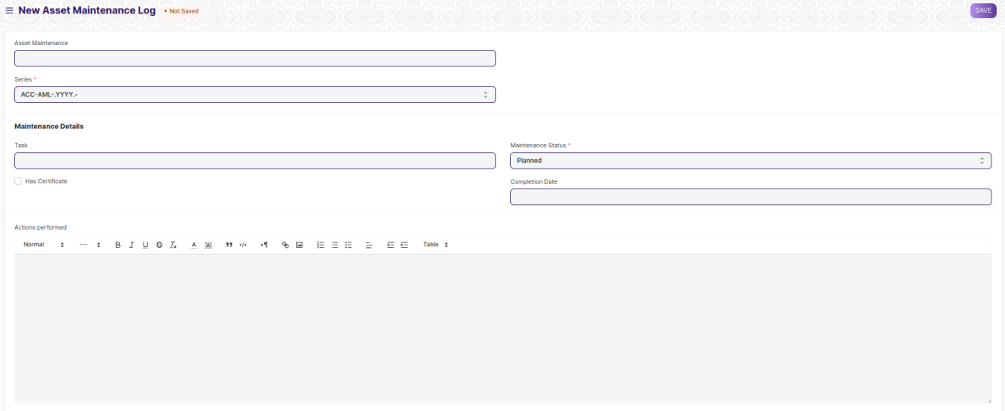

Figure 8: Asset Maintenance Log Screen

**UI Fields**

The “Asset Maintenance Log” screen shall consist of the following fields:

|  |  |  |  |  |  |  |
| --- | --- | --- | --- | --- | --- | --- |
| **ID** | **Field Label** | **Field Type** | **Validation/ Action** | **Mandatory** | **Remarks** | **R/N/D** |
| 1 | Asset Maintenance | Link | Fetched from Asset Maintenance screen |  |  |  |
| 2 | Series | Dropdown | ACC-AML-.YYYY.- | Yes |  |  |
| 3 | Asset Name | Read Only | Fetched from Asset Maintenance asset |  |  |  |
| 4 | Item Code | Read Only | Fetched from Asset Maintenance asset |  |  |  |
| 5 | Item Name | Read Only | Fetched from Asset Maintenance asset |  |  |  |
| 6 | Task | Link | Fetched from Task screen |  |  |  |
| 7 | Task Name | Text Field | User Input |  |  |  |
| 8 | Maintenance Type | Read Only | Fetched from Task asset |  |  |  |
| 9 | Periodicity | Text Field | User Input |  |  |  |
| 10 | Has Certificate | Checkbox | User Input |  |  |  |
| 11 | Certificate | Attach | User Input |  |  |  |
| 12 | Maintenance Status | Dropdown | Planned/ Completed /  Cancelled / Overdue | Yes |  |  |
| 13 | Assign To | Read Only | Fetched from Task asset |  |  |  |
| 14 | Due Date | Date | User Input |  |  |  |
| 15 | Completion Date | Date | User Input |  |  |  |
| 16 | Description | Read Only | Fetched from Task asset |  |  |  |
| 17 | Actions performed | Text Editor | User Input |  |  |  |

**Users: Roles and Permissions**

The following table describes the users and their roles and permissions for the screens :

|  |  |  |  |  |  |  |  |  |  |
| --- | --- | --- | --- | --- | --- | --- | --- | --- | --- |
| **ID** | **Role** | **Select** | **Read** | **Write** | **Create** | **Delete** | **Submit** | **Cancel** | **Amend** |
|  | Building Administrator | No | Yes | No | No | No | No | No | No |
|  | Floor Supervisor | No | Yes | No | No | No | No | No | No |
|  | Maintenance Department | Yes | Yes | Yes | Yes | Yes | Yes | Yes | Yes |
|  | Employee | No | Yes | No | No | No | No | No | No |

## Asset Repair

**General Description**

The Following table describe overall information about this screen:

|  |  |
| --- | --- |
| **Description** | Asset Repair refers to any activity carried to repair a broken Asset to restore full functionality. |
| **Navigation** | Home > Material Management > Maintenance> Asset Repair |
| **Pre-requisites** | 1. Asset |

**Screenshot**

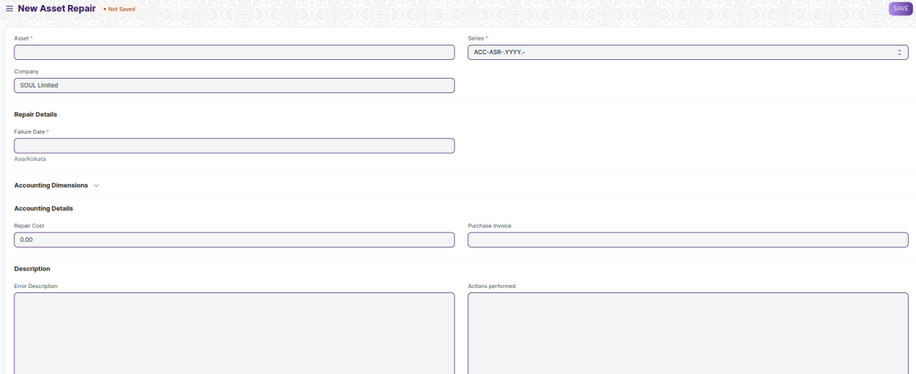

Figure 9: Asset Repair Screen

**UI Fields**

The “Asset Repair” screen shall consist of the following fields:

|  |  |  |  |  |  |  |
| --- | --- | --- | --- | --- | --- | --- |
| **ID** | **Field Label** | **Field Type** | **Validation/ Action** | **Mandatory** | **Remarks** | **R/N/D** |
| 1 | Asset | Link | Fetched from Asset Maintenance screen | Yes |  |  |
| 2 | Company | Link | Fetched from Asset Maintenance screen |  |  |  |
| 3 | Asset Name | Read Only | Fetched from value in Asset field |  |  |  |
| 4 | Series | Dropdown | ACC-ASR-.YYYY.- | Yes |  |  |
| 5 | Failure Date | Datetime | User Input | Yes |  |  |
| 6 | Repair Status | Dropdown | Pending / completed /Cancelled |  |  |  |
| 7 | Completion Date | Datetime | User Input |  |  |  |
| 8 | Address | Link | Fetched from Address screen |  |  |  |
| 9 | Article | Link | Fetched from Article screen |  |  |  |
| 10 | Cost Center | Link | Fetched from Cost center screen |  |  |  |
| 11 | Project | Link | Fetched from Project screen |  |  |  |
| 12 | Repair Cost | Currency | User Input |  |  |  |
| 13 | Capitalize Repair Cost | Checkbox | User Input |  |  |  |
| 14 | Stock Consumed During Repair | Checkbox | User Input |  |  |  |
| 15 | Purchase Invoice | Link | Fetched from Purchase Invoice screen |  |  |  |
| 16 | Warehouse | Link | Fetched from Warehouse screen |  |  |  |
| 17 | **Stock Items** | Table |  |  | These table is describe below |  |
| 18 | Total Repair Cost | Currency | User Input |  |  |  |
| 19 | Stock Entry | Link | Fetched from Stock Entry screen |  |  |  |
| 20 | Increase In Asset Life(Months) | Int | User Input |  |  |  |
| 21 | Error Description | Long Text | User Input |  |  |  |
| 22 | Actions performed | Long Text | User Input |  |  |  |
| 23 | Downtime | Text Field | User Input |  |  |  |
| 24 | View General Ledger | Button | On click of the button you can General ledger for the Asset repair |  |  |  |

|  |  |  |  |  |  |  |
| --- | --- | --- | --- | --- | --- | --- |
| **Stock Items (Child Table)** | | | | | | |
| **ID** | **Field Label** | **Field Type** | **Validation/ Action** | **Mandatory** | **Remarks** | **R/N/D** |
| 1 | Item | Link | Fetched from Item screen |  |  |  |
| 2 | Valuation Rate | Currency | User Input |  |  |  |
| 3 | Consumed Quantity | Text Field | User Input |  |  |  |
| 4 | Total Value | Currency | User Input |  |  |  |
| 5 | Serial No | Small Text | User Input |  |  |  |

**Users: Roles and Permissions**

The following table describes the users and their roles and permissions for the screens :

|  |  |  |  |  |  |  |  |  |  |
| --- | --- | --- | --- | --- | --- | --- | --- | --- | --- |
| **ID** | **Role** | **Select** | **Read** | **Write** | **Create** | **Delete** | **Submit** | **Cancel** | **Amend** |
|  | Building Administrator | No | Yes | No | No | No | No | No | No |
|  | Floor Supervisor | No | Yes | No | No | No | No | No | No |
|  | Maintenance Department | Yes | Yes | Yes | Yes | Yes | Yes | Yes | Yes |
|  | Employee | No | Yes | No | No | No | No | No | No |